**1. Project Title**          New on-air sites tracker

**2. Problem in Brief**

* In the current situation, there’s very poor communication between users’ group most of the time the INOC Team is not aware of their sites.
* No single system to capture the process of sites. (table 1)
* It is taken the more time to find sites recodes of define sites and the progress of sites.
* It may difficult to obtain the details of the site from define sites and separately identify the On-air site.
* When considering the current system, the occurrence of human errors is ordinary and hard to handle manual data.

Table 1: Process of sites activity

|  |  |  |
| --- | --- | --- |
| Group ID | User Group | Activity |
| 1 | RNP & RNO | Define sites |
| 2 | RAO | Configure in systems (U2000/EMS) & update site configuration status |
| 3 | CS | Configure in MSC & Update configuration status |
| 4 | PCN | Configure in SGSN & Update configuration status |
| 5 | Vendor | Configure in systems (U2000/EMS) & update site configuration status |
| 6 | RO | Update PAT status |
| 7 | INOC | On-air site |

**3. Proposed Solution**

* We are going to develop a system that facilitates the interconnection between users’ group by a web application.
* Easy and quickly update single or multi define sites separate user groups.
* Quickly find the details of the site.
* This system can be minimized human errors, reduce time-wasting than manual system and enhance the quality of new on-air sites.

**4. Requirements identification**

4.1   Functional requirement

* Add and remove new sites by RNP & RNO. (single sites or multi-sites)
* View all site details and search sites.
* Configure in systems (U2000/EMS) and Update site configuration status.
* Configure in MSC and Update configuration status.
* Configure in SGSN and Update configuration status.
* Update PAT status.
* Define the On-air site and show the count of On-air sites.
* Mail and SMS function-> A message is sent to the requestor about the response of the cell block request.
* Can export the records. (date range or all records as the excel sheet)

4.2 Non-functional requirements

* Usability. (Color combination is valid for even color-blind people, User interface responsive to any device)
* User-friendliness – adding icons and information messages.
* Increasing Performance. (AJAX form submit use to data insert and search, using table plugging)
* Security- prevent unauthorized access and SQL injection by using security functions.
* Data adding and update are not reflecting with other accounts.
* Reliability.

4.3 User levels

* RNP & RNO
* RAO
* CS
* PCN
* Vendor (Huawei, ZTE)
* RO
* INOC

4.4 User Roles

|  |  |  |  |
| --- | --- | --- | --- |
| Group ID | User Group | Access level | Functions |
| 1 | RNP & RNO |  | Add new sites. (single sites or multi-sites)  View and search site details. |
| 2 | RAO |  | Update site configuration status. (single or multi)  View and search site details. |
| 3 | CS |  | Update site configuration status and remark. (single or multi)  View and search site details. |
| 4 | PCN |  | Update site configuration status and remark. (single or multi)  View and search site details. |
| 5 | Vendor |  | Update site configuration status and remark. (single or multi)  View and search site details. |
| 6 | RO |  | Update PAT status and remark. (single or multi)  View and search site details. |
| 7 | INOC |  | On-air site. (single or multi)  View and search site details. |

**5. Interfaces**

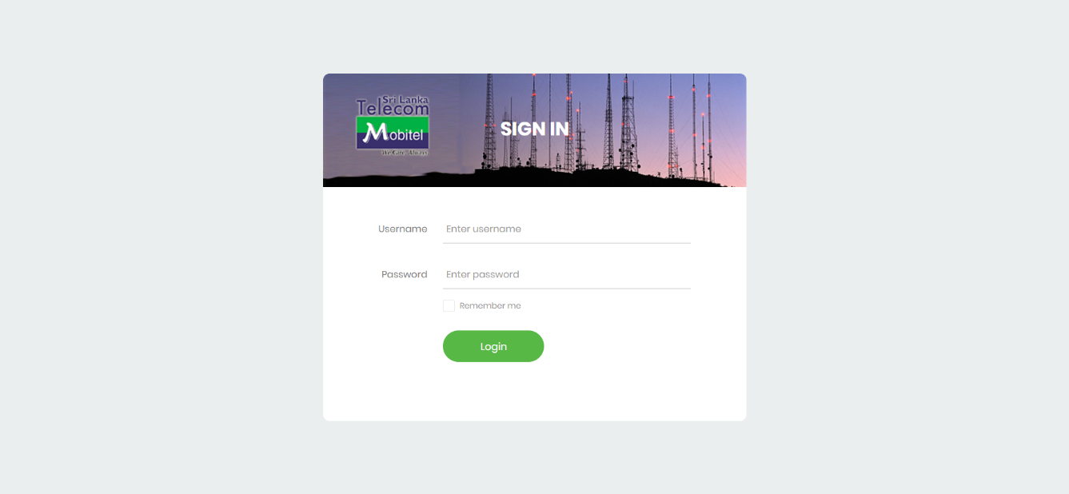

Figure 1: User Login

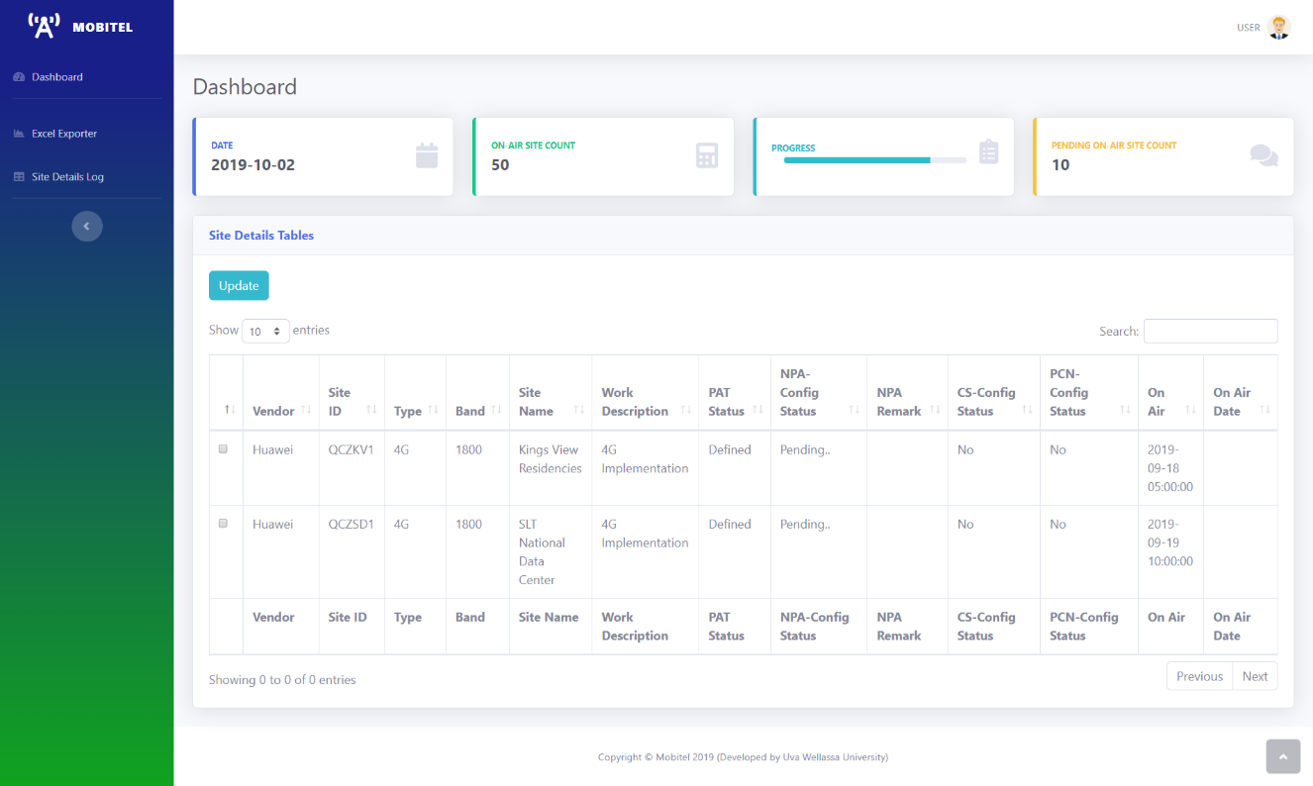

Figure 2: Dashboard

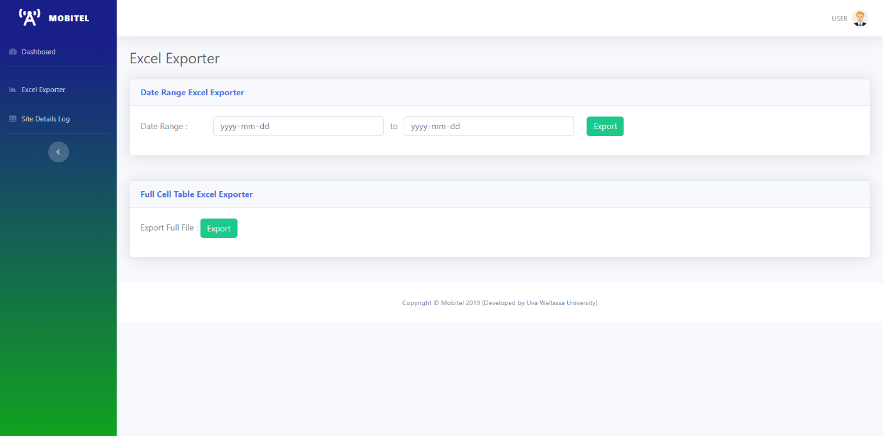

Figure 3: Excel Exporter

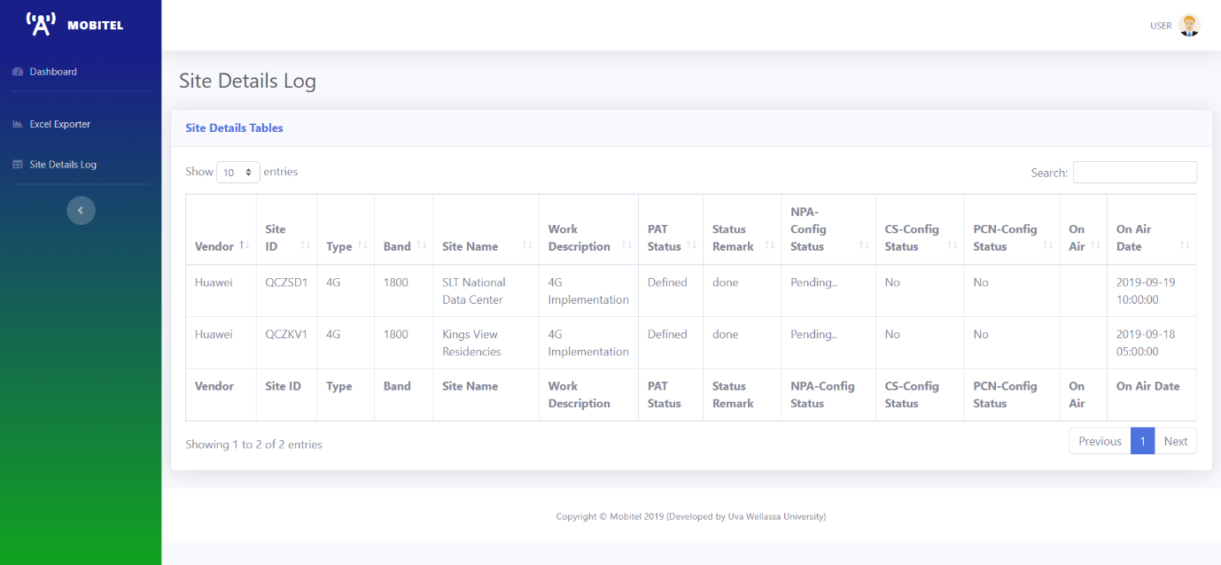

Figure 4: Site Details Log